Greedy Regret Heuristics
Students
- Patrick Molina, 157419
- Chihabeddine Zitouni, 158753

Code Repository
https://github.com/patrickmolina1/Evolutionary-Computation

Problem Description
The task is to select a subset of nodes and form an optimal Hamiltonian cycle minimizing the total cost and travel distance. Each node is defined by three attributes: x-coordinate, y-coordinate, and cost. Exactly 50% of the nodes must be selected (rounded up if the total number is odd). The goal is to minimize the sum of the cycle length and the total cost of the selected nodes. Distances between nodes are computed using the Euclidean distance, rounded to the nearest integer. A distance matrix is precomputed after reading each instance and used throughout the optimization process, allowing instances to be represented solely by distance values

Methods
Extended version of the nearest neighbor heuristic and the greedy cycle heuristic:
- Greedy 2-regret heuristics.
- Greedy heuristics with a weighted sum criterion – 2-regret + best change of the objective function. By default, use equal weights but you can also experiment with other values

Computational experiment

CPU Specs
AMD Ryzen 7 5800H with Radeon Graphics
Cores | Threads | Clockspeed | Turbo Speed
8 | 16 | 3.2 GHz | 4.4 GHz

Pseudocode
Algorithm: Greedy 2-Regret Nearest Neighbor
Input: instance, startNode
Output: solution
- Initialize selected ← [startNode], order ← [startNode.id]
- Initialize remaining ← all nodes except startNode
- Calculate numToSelect ← ⌈n/2⌉
- While selected.size < numToSelect AND remaining is not empty:
- Step 1: Find best candidate based on regret
- Set bestCandidateToAdd ← null, maxRegret ← -∞
- For each candidate in remaining:
- Set minDistanceToTour ← ∞, secondMinDistanceToTour ← ∞
- For each inTour node in selected:
    - Get distance ← dist[inTour.id][candidate.id]
    - If distance < minDistanceToTour:
      - secondMinDistanceToTour ← minDistanceToTour
      - minDistanceToTour ← distance
    - Else if distance < secondMinDistanceToTour:
      - secondMinDistanceToTour ← distance
- Calculate bestMetric ← minDistanceToTour + candidate.cost
- Calculate secondBestMetric ← secondMinDistanceToTour + candidate.cost
- Calculate regret ← secondBestMetric – bestMetric
- If regret > maxRegret:
    - maxRegret ← regret
    - bestCandidateToAdd ← candidate
- Step 2: Find best position to insert selected candidate
- If bestCandidateToAdd is not null:
- Set bestPosition ← -1, minIncrease ← ∞
- For each position pos in cycle (0 to order.size):
    - Get prevNodeId ← order[pos]
    - Get nextNodeId ← order[(pos + 1) % order.size]
    - Calculate objectiveIncrease ← (dist[prev][candidate] + dist[candidate][next] - dist[prev][next]) + candidate.cost
    - If objectiveIncrease < minIncrease:
      - minIncrease ← objectiveIncrease
      - bestPosition ← pos + 1
- Insert bestCandidateToAdd into selected at bestPosition
- Insert bestCandidateToAdd.id into order at bestPosition
- Remove bestCandidateToAdd from remaining
- Else break
- Calculate totalDistance by summing distances along cycle
- Calculate totalNodeCost by summing node costs
- Calculate totalCost ← totalDistance + totalNodeCost
- Return solution with selected, order, totalCost, totalDistance
Algorithm: Greedy Weighted Regret Nearest Neighbor
Input: instance, startNode, weightRegret, weightObjective
Output: solution
- Initialize selected ← [startNode], order ← [startNode.id]
- Initialize remaining ← all nodes except startNode
- Calculate numToSelect ← ⌈n/2⌉
- While selected.size < numToSelect AND remaining is not empty:
- Set bestCandidateToAdd ← null, maxWeightedScore ← -∞
- For each candidate in remaining:
- Set minDistanceToTour ← ∞, secondMinDistanceToTour ← ∞
- For each inTour node in selected:
    - Get distance ← dist[inTour.id][candidate.id]
    - If distance < minDistanceToTour:
      - secondMinDistanceToTour ← minDistanceToTour
      - minDistanceToTour ← distance
    - Else if distance < secondMinDistanceToTour:
      - secondMinDistanceToTour ← distance
- Calculate bestMetric ← minDistanceToTour + candidate.cost
- Calculate secondBestMetric ← secondMinDistanceToTour + candidate.cost
- Calculate regret ← secondBestMetric – bestMetric
- Calculate weightedScore ← weightRegret × regret - weightObjective × bestMetric
- If weightedScore > maxWeightedScore:
    - maxWeightedScore ← weightedScore
    - bestCandidateToAdd ← candidate
- If bestCandidateToAdd is not null:
- Set bestPosition ← -1, minIncrease ← ∞
- For each position pos in cycle (0 to order.size):
    - Get prevNodeId ← order[pos]
    - Get nextNodeId ← order[(pos + 1) % order.size]
    - Calculate objectiveIncrease ← (dist[prev][candidate] + dist[candidate][next] - dist[prev][next]) + candidate.cost
    - If objectiveIncrease < minIncrease:
      - minIncrease ← objectiveIncrease
      - bestPosition ← pos + 1
- Insert bestCandidateToAdd into selected at bestPosition
- Insert bestCandidateToAdd.id into order at bestPosition
- Remove bestCandidateToAdd from remaining
- Else break
- Calculate totalDistance by summing distances along cycle
- Calculate totalNodeCost by summing node costs
- Calculate totalCost ← totalDistance + totalNodeCost
- Return solution with selected, order, totalCost, totalDistance

Algorithm: Greedy 2-Regret Greedy Cycle
Input: instance, startNode
Output: solution
- Initialize selected ← [startNode], order ← [startNode.id]
- Initialize remaining ← all nodes except startNode
- Calculate numToSelect ← ⌈n/2⌉
- While selected.size < numToSelect AND remaining is not empty:
- Set bestCandidate ← null, bestPosition ← -1, maxRegret ← -∞
- For each candidate in remaining:
- Set bestIncrease ← ∞, secondBestIncrease ← ∞, bestPos ← -1
- For each position pos in cycle (0 to order.size):
    - Get prevNodeId ← order[pos]
    - Get nextNodeId ← order[(pos + 1) % order.size]
    - Calculate objectiveIncrease ← (dist[prev][candidate] + dist[candidate][next] - dist[prev][next]) + candidate.cost
    - If objectiveIncrease < bestIncrease:
      - secondBestIncrease ← bestIncrease
      - bestIncrease ← objectiveIncrease
      - bestPos ← pos + 1
    - Else if objectiveIncrease < secondBestIncrease:
      - secondBestIncrease ← objectiveIncrease
- Calculate regret ← (secondBestIncrease == ∞) ? bestIncrease : (secondBestIncrease - bestIncrease)
- If regret > maxRegret:
    - maxRegret ← regret
    - bestCandidate ← candidate
    - bestPosition ← bestPos
- If bestCandidate is not null:
  - Insert bestCandidate into selected at bestPosition
  - Insert bestCandidate.id into order at bestPosition
  - Remove bestCandidate from remaining
- Else break
- Calculate totalDistance by summing distances along cycle
- Calculate totalNodeCost by summing node costs
- Calculate totalCost ← totalDistance + totalNodeCost
- Return solution with selected, order, totalCost, totalDistance

Algorithm: Greedy Weighted Regret Greedy Cycle
Input: instance, startNode, weightRegret, weightObjective
Output: solution
- Initialize selected ← [startNode], order ← [startNode.id]
- Initialize remaining ← all nodes except startNode
- Calculate numToSelect ← ⌈n/2⌉
- While selected.size < numToSelect AND remaining is not empty:
- Set bestCandidate ← null, bestPosition ← -1, maxWeightedScore ← -∞
- For each candidate in remaining:
- Set bestIncrease ← ∞, secondBestIncrease ← ∞, bestPos ← -1
- For each position pos in cycle (0 to order.size):
    - Get prevNodeId ← order[pos]
    - Get nextNodeId ← order[(pos + 1) % order.size]
    - Calculate objectiveIncrease ← (dist[prev][candidate] + dist[candidate][next] - dist[prev][next]) + candidate.cost
    - If objectiveIncrease < bestIncrease:
      - secondBestIncrease ← bestIncrease
      - bestIncrease ← objectiveIncrease
      - bestPos ← pos + 1
    - Else if objectiveIncrease < secondBestIncrease:
      - secondBestIncrease ← objectiveIncrease
- Calculate regret ← (secondBestIncrease == ∞) ? bestIncrease : (secondBestIncrease - bestIncrease)
- Calculate weightedScore ← weightRegret × regret - weightObjective × bestIncrease
- If weightedScore > maxWeightedScore:
    - maxWeightedScore ← weightedScore
    - bestCandidate ← candidate
    - bestPosition ← bestPos
- If bestCandidate is not null:
  - Insert bestCandidate into selected at bestPosition
  - Insert bestCandidate.id into order at bestPosition
  - Remove bestCandidate from remaining
- Else break
- Calculate totalDistance by summing distances along cycle
- Calculate totalNodeCost by summing node costs
- Calculate totalCost ← totalDistance + totalNodeCost
- Return solution with selected, order, totalCost, totalDistance

Results

Method | Instance A | Instance B
greedy2RegretNN | 121200.87 (111728 - 130895) | 74916.32 (69992 – 79154)
greedyWeightedRegretNN | 72555.99 (71373 – 73970) | 48853.80 (46862 – 51266)
greedy2RegretGreedyCycle | 116942.80 (110039 - 125138) | 72817.32 (67658 – 77816)
greedyWeightedRegretGreedyCycle | 71888.03 (70700 – 73381) | 50278.91 (47609 – 54296)

Random Solution | 264419.52 (230885 – 300429) | 213914.41 (191803 - 235581)
Nearest Neighbor End Only | 103674.65 (90323 - 117672) | 69828.78 (62606 - 77415)
Nearest Neighbor All Positions | 72334.99 (71515 - 73823) | 48994.88 (47295 – 51030)
Greedy Cycle | 72598.91 (71488 - 74410) | 51532.22 (49001 – 57324)

Running Times(ms)

Method | Instance A | Instance B
greedy2RegretNN | 4.01 (1 - 43) | 5.01 (1 - 69)
greedyWeightedRegretNN | 3.88 (1 - 34) | 5.02 (1 - 62)
greedy2RegretGreedyCycle | 5.28 (3 - 59) | 5.95 (3 - 46)
greedyWeightedRegretGreedyCycle | 5.40 (3 - 105) | 5.89 (2 - 105)

Method | Instance A | Instance B
Random Solution | 0.06 (0 - 3) | 0.07 (0 - 4)
Nearest Neighbor End Only | 0.25 (0 - 3) | 0.30 (0 - 3)
Nearest Neighbor All Positions | 1.78 (0 - 13) | 2.08 (0 - 13)
Greedy Cycle | 2.32 (1 - 22) | 2.37 (1 - 23)

Best Solution

Instance A

Greedy 2 Regret NN
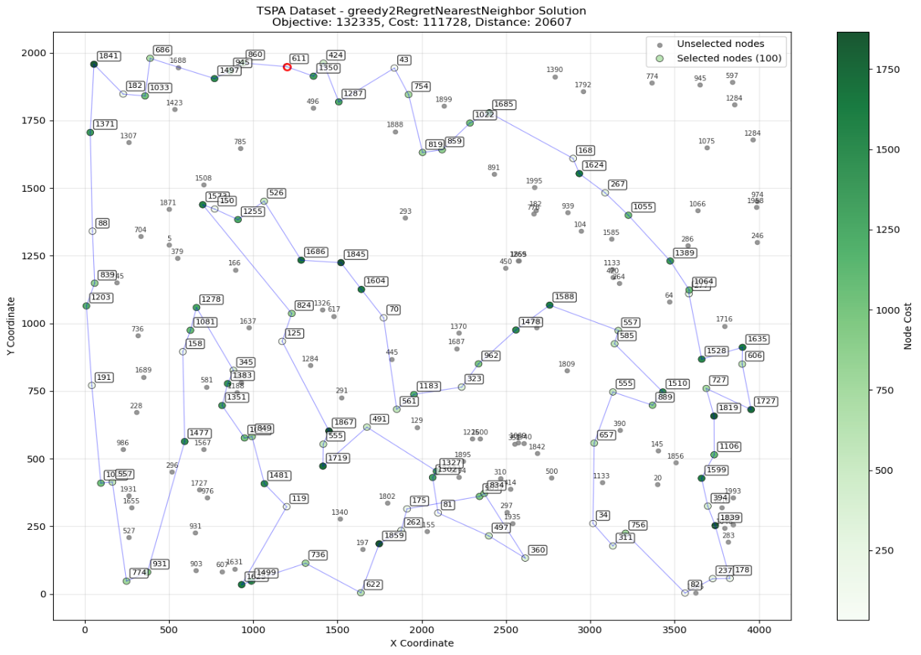

Greedy Weighted Regret NN
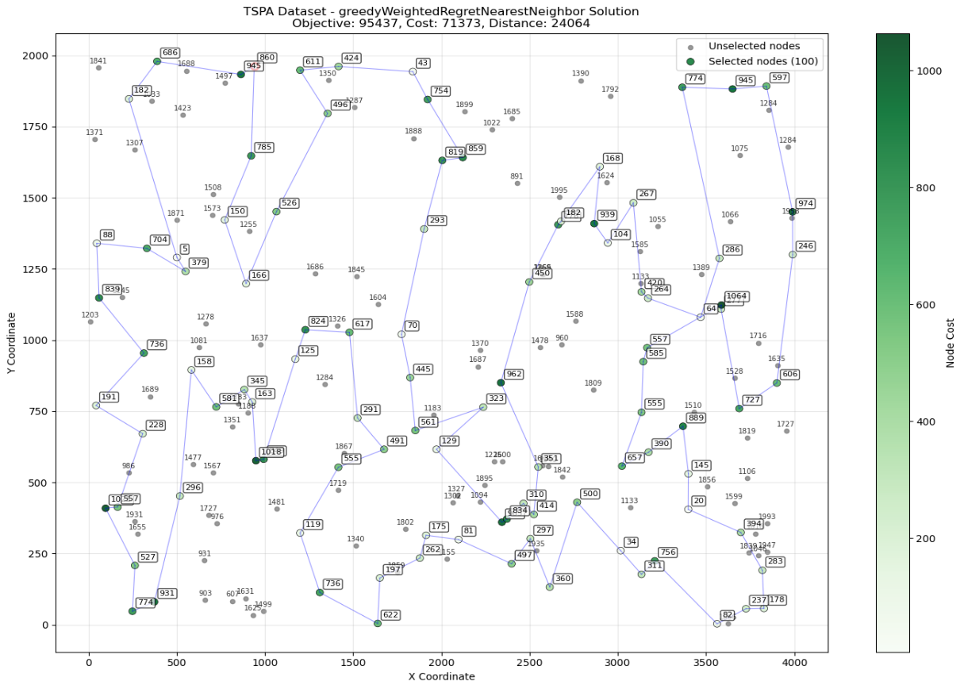

Greedy 2 Regret GeedyCycle
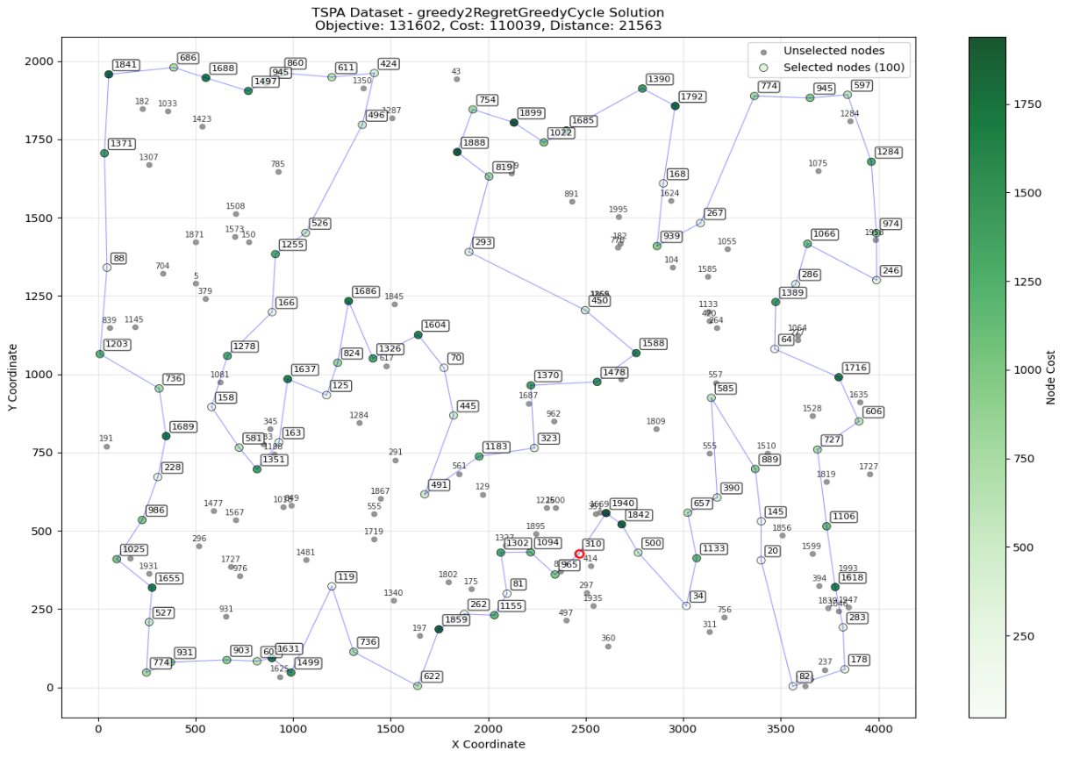

Greedy Weighted Regret Greedy Cycle
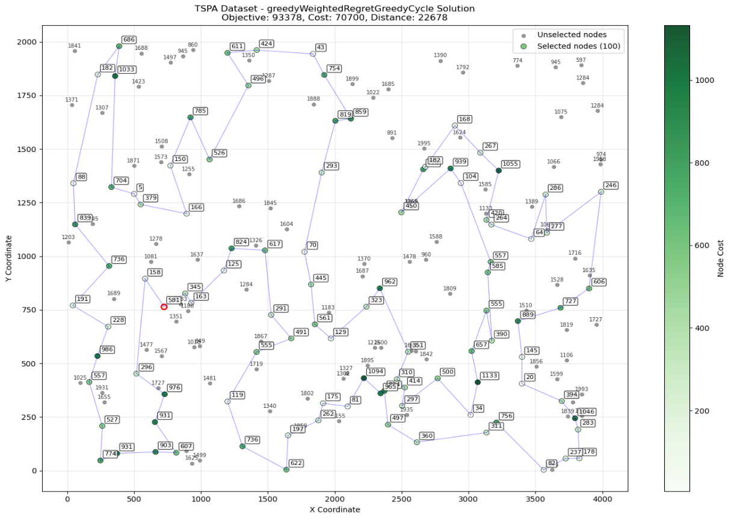

Instance B

Greedy 2 Regret NN
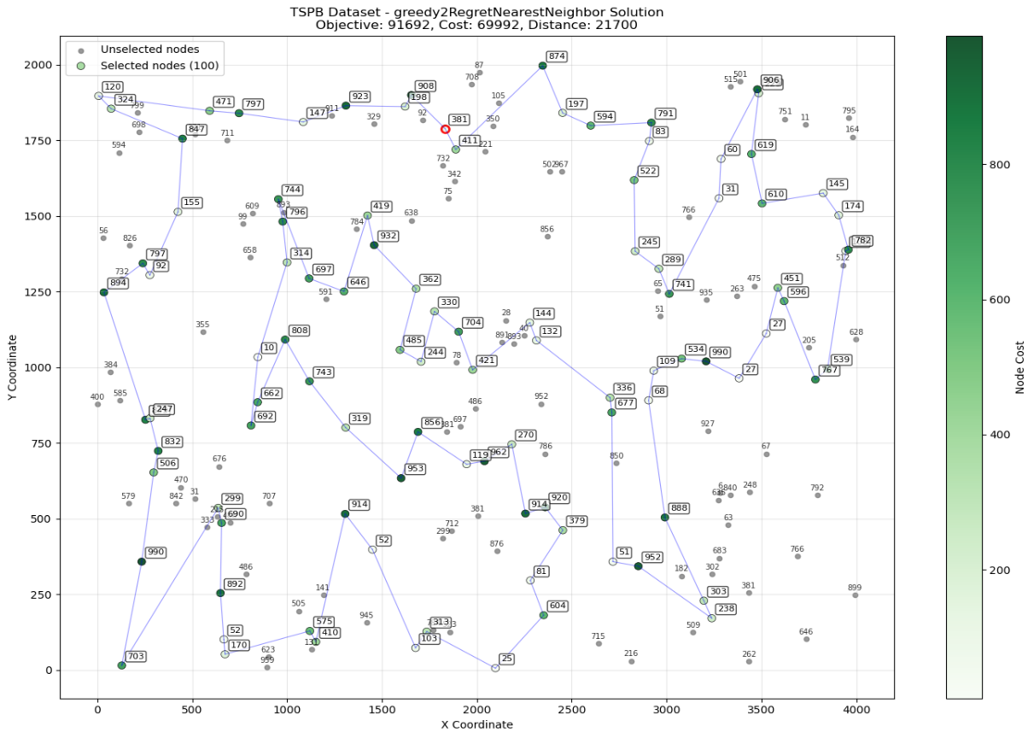

Greedy Weighted Regret NN
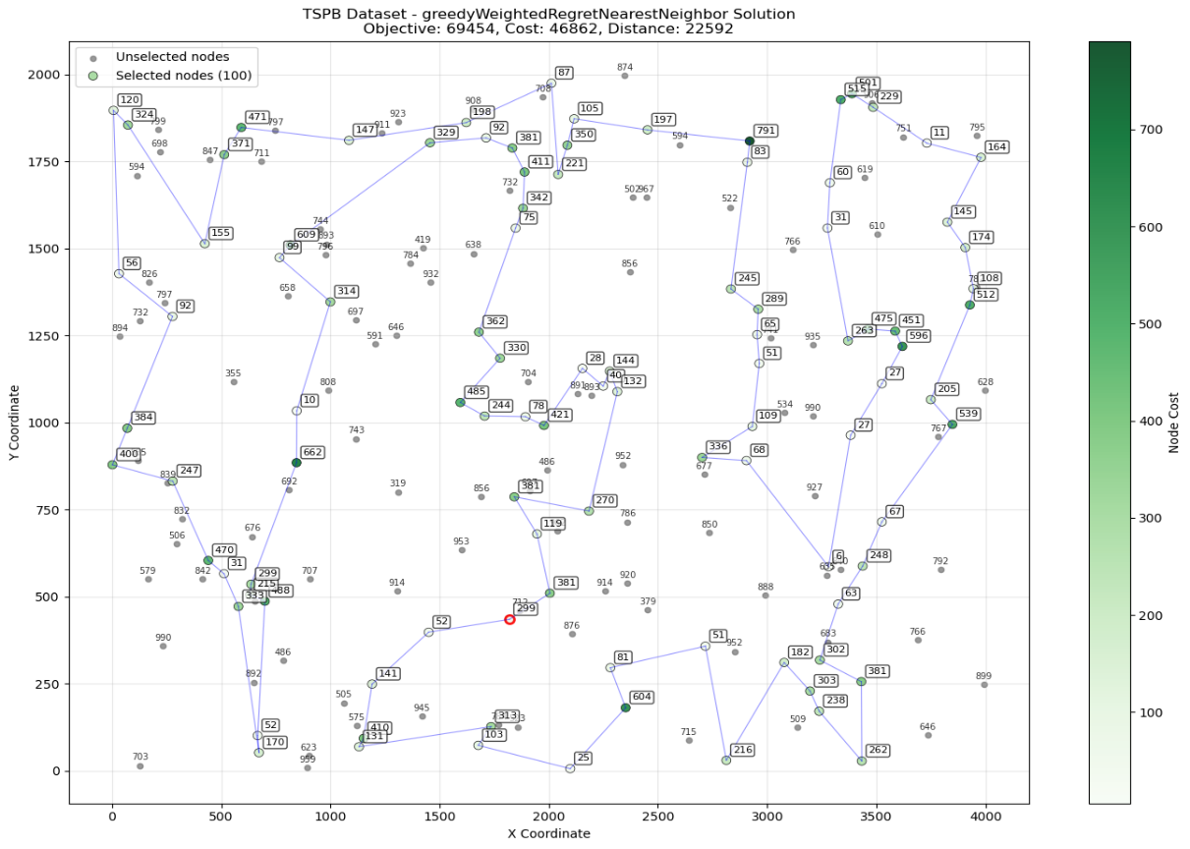

Greedy 2 Regret Greedy Cycle
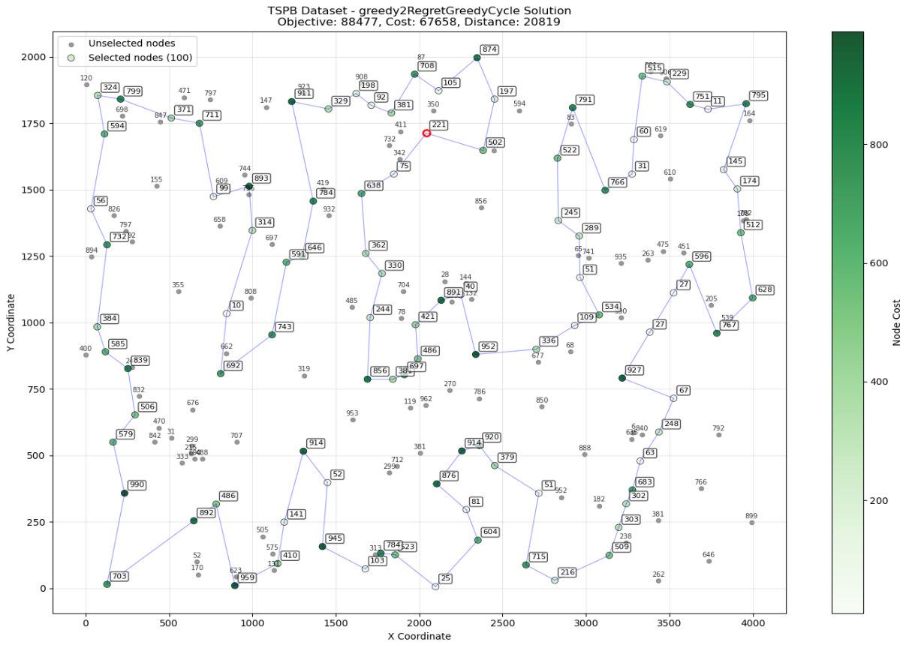

Greedy Weighted Regret Greedy Cycle

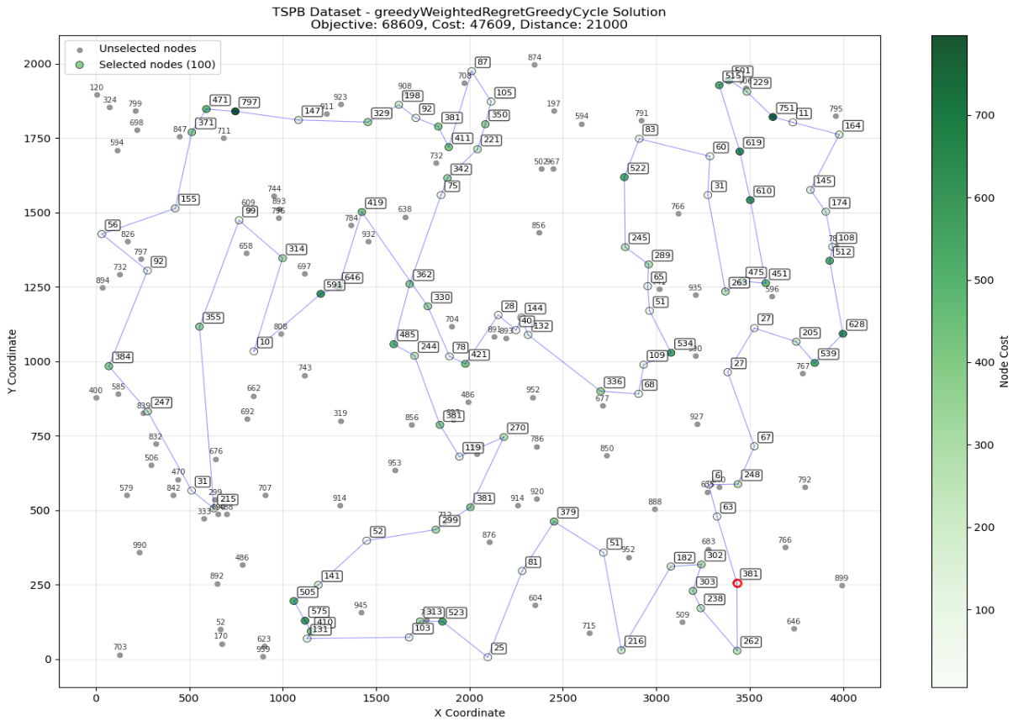

Cycles

Instance A

Greedy 2 Regret NN
117-93-140-36-108-69-18-134-20-22-146-103-34-30-54-10-190-28-42-5-96-116-105-77-131-149-24-123-156-29-127-70-6-154-180-100-26-75-86-53-136-182-133-161-162-45-59-118-191-139-198-46-60-141-66-176-79-122-94-124-111-128-52-55-91-179-57-129-120-44-25-16-171-175-13-31-38-157-17-196-98-81-187-169-40-119-8-138-14-155-144-64-114-186-23-89-183-153-143-170

Greedy Weighted Regret NN
93-68-139-115-46-0-117-143-183-89-186-23-137-176-80-79-94-63-100-26-97-1-152-124-148-9-62-144-102-49-14-178-106-185-165-21-7-164-27-90-81-196-40-119-52-55-57-129-92-179-145-78-31-113-175-171-16-25-44-120-2-75-101-86-53-180-154-135-70-127-123-162-133-151-51-118-59-149-131-65-116-43-42-184-190-10-177-30-54-160-34-181-146-22-159-41-193-18-108-140

Greedy 2 Regret Greedy Cycle
97-125-87-2-120-82-129-92-55-179-145-78-16-175-113-85-157-196-81-174-185-8-165-39-90-27-71-164-7-21-14-102-144-132-73-64-114-83-89-76-23-137-148-128-111-12-94-122-133-80-176-66-109-60-118-59-197-65-77-43-42-96-115-198-46-0-143-117-93-140-36-67-108-134-20-22-103-181-192-160-48-30-104-177-10-190-4-112-126-29-123-127-70-6-154-158-53-136-121-100

Greedy Weighted Regret Greedy Cycle
43-42-184-35-84-112-4-190-10-177-54-48-160-34-181-146-22-18-108-69-159-193-41-115-139-68-46-0-117-143-183-89-186-23-137-176-80-79-63-94-124-152-97-1-101-2-120-82-129-57-92-55-52-49-102-148-9-62-144-14-138-178-106-185-165-40-90-81-196-179-145-78-31-56-113-175-171-16-25-44-75-86-26-100-121-53-180-154-135-70-127-123-162-133-151-51-118-59-65-116

Instance B

Greedy 2 Regret NN
132-65-188-150-147-115-10-40-107-44-122-135-32-92-197-1-24-156-196-108-54-164-105-190-80-142-78-123-177-36-61-141-97-77-81-14-50-111-68-8-157-171-25-158-116-112-19-121-51-120-71-98-74-134-2-139-182-138-11-49-160-109-35-143-159-153-186-127-89-129-106-124-128-110-86-185-99-22-52-172-94-154-47-148-9-199-28-101-140-183-83-55-34-170-152-53-184-155-84-13

Greedy Weighted Regret NN
21-177-5-78-175-61-36-141-97-77-153-187-163-89-127-137-114-103-113-194-166-172-179-66-94-47-148-60-20-28-149-4-140-183-95-130-99-22-185-86-176-106-143-124-62-18-55-34-152-53-155-3-15-145-70-188-147-10-133-122-107-40-63-135-38-27-1-198-117-193-80-190-73-31-54-112-121-51-90-191-6-169-132-13-195-168-139-11-182-138-33-160-29-0-109-35-111-104-8-82

Greedy 2 Regret Greedy Cycle
145-168-43-139-11-138-157-104-56-144-160-39-0-37-143-124-128-62-55-34-170-53-174-183-140-4-28-59-20-23-148-47-66-57-52-22-185-86-64-166-194-113-26-103-89-165-187-146-153-81-14-50-58-77-97-141-91-79-36-7-177-123-5-78-46-136-105-108-196-42-156-197-16-38-102-63-100-107-17-133-178-90-67-51-121-19-158-118-74-85-192-6-188-169-132-161-3-84-155-189

Greedy Weighted Regret Greedy Cycle
114-113-176-194-166-86-185-179-172-57-66-94-47-148-60-20-59-28-149-4-199-9-99-130-95-183-140-152-170-34-55-18-62-128-124-106-143-35-109-0-29-160-33-11-134-74-118-121-51-90-131-31-117-1-38-135-63-122-133-10-115-147-6-188-169-132-13-70-3-15-145-195-168-139-182-138-104-8-111-82-21-177-5-45-142-78-175-36-61-91-141-77-81-153-187-163-103-89-127-137

Conclusion
- The experimental evaluation of regret-based construction heuristics demonstrates the effectiveness of incorporating opportunity cost considerations into greedy decision-making revealing that regret-based methods consistently produce competitive solutions compared to their standard greedy counterparts, in this case having weighted + 2 regret methods solutions has good results an and even the best one for instance A, but for instance B NN-all possible is still the best.
- The weighted regret approaches demonstrate that balancing immediate gains with opportunity costs through equal weights (or experimentally tuned weights) can effectively navigate the trade-off between exploiting current best options and preserving future construction flexibility.
- Visualization of best solutions reveals that regret-based methods tend to select nodes more strategically, avoiding premature commitment to locally attractive but globally suboptimal choices that would constrain subsequent decisions.

